**Experiment 4: Xml**

**Aim:** To write an xml file that can display information

**Tags Used:**

<note>

<art>

<head>

<foot>

**Implementation:**

**Output:**

**https://kuldeep1628.github.io/xml-demo/**

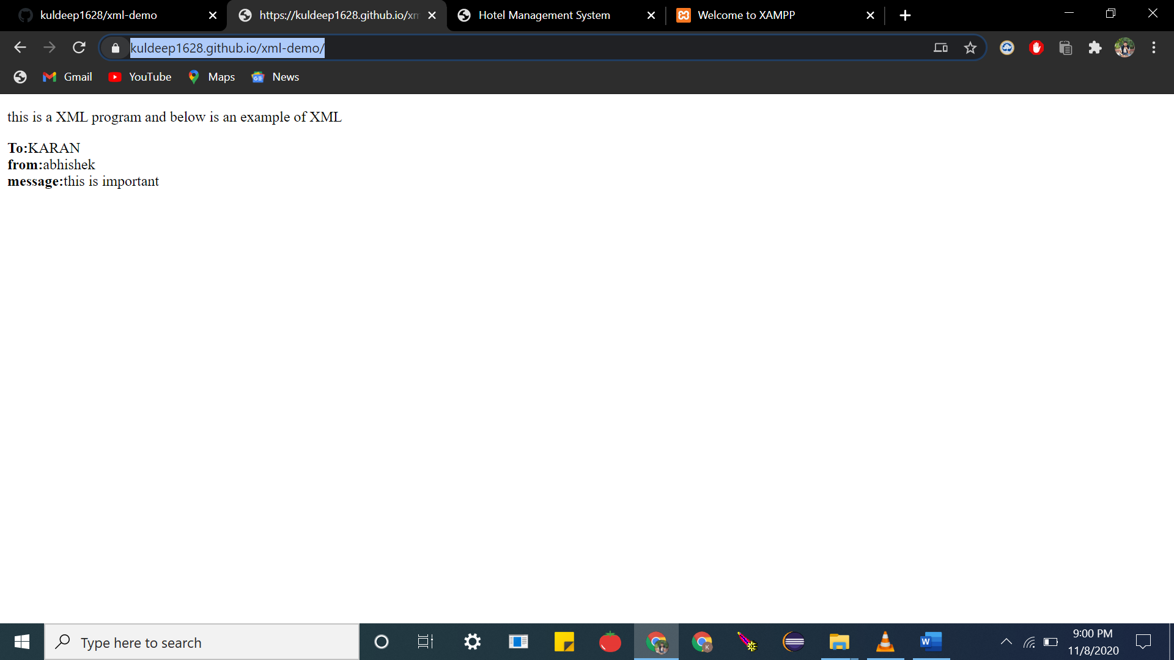

**Code:**

**Index.html**

|  |
| --- |
| <!DOCTYPE html> |
|  | <html> |
|  |  |
|  | <body> |
|  | <p>this is a XML program and below is an example of XML</p> |
|  | <div> |
|  | <b>To:</b><span id="to"></span><br> |
|  | <b>from:</b><span id="from"></span><br> |
|  | <b>message:</b><span id="message"></span><br> |
|  | </div> |
|  | <script> |
|  | if (window.XMLHttpRequest) { |
|  | xmlhttp = new XMLHttpRequest(); |
|  | } |
|  | else { |
|  | xmlhttp = new ActiveXObject("Microsoft.XMLHTTP"); |
|  | } |
|  | xmlhttp.onreadystatechange = function () { |
|  | if (this.readyState == 4 && this.status == 200) { |
|  | xmlDoc = xmlhttp.responseXML; |
|  | document.getElementById("to").innerHTML = xmlDoc.getElementsByTagName("to")[0].childNodes[0].nodeValue; |
|  | document.getElementById("from").innerHTML = xmlDoc.getElementsByTagName("from")[0].childNodes[0].nodeValue; |
|  | document.getElementById("message").innerHTML = xmlDoc.getElementsByTagName("body")[0].childNodes[0].nodeValue; |
|  | } |
|  | }; |
|  | xmlhttp.open("GET", "demo.xml", true); |
|  | xmlhttp.send(); |
|  |  |
|  |  |
|  |  |
|  | </script> |
|  |  |
|  | </body> |
|  |  |
|  | </html> |

**Demo.xml**

|  |
| --- |
| <?xml version="1.0" encoding="UTF-8"?> |
|  | <note> |
|  | <to>KARAN</to> |
|  | <from>abhishek</from> |
|  | <heading>reminder</heading> |
|  | <body>this is important</body> |
|  | </note> |

**Result:**The experiment was successfully completed.